SHABARISH N 192424007
8085 Simulator
8-BIT ADDITION WITH CARRY USING DIRECT ADDRESSING
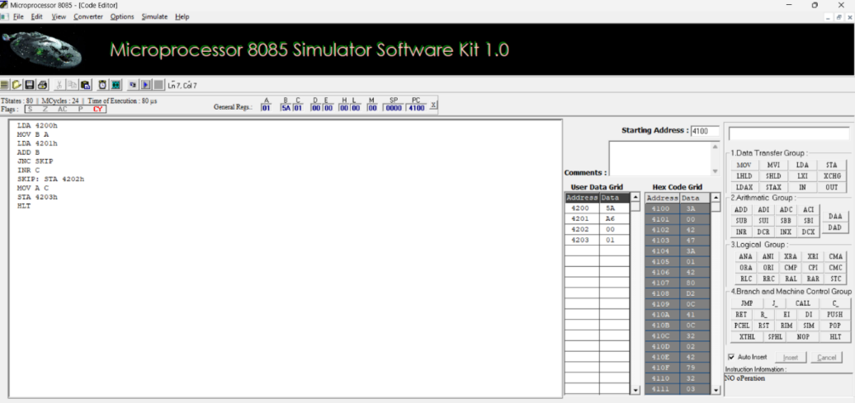
b. 8-BIT ADDITION USING INDIRECT ADDRESSING
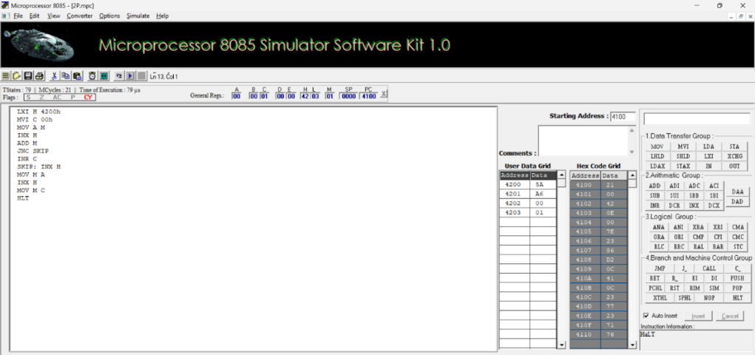
c. 8-BIT SUBTRACTION WITHOUT BORROW
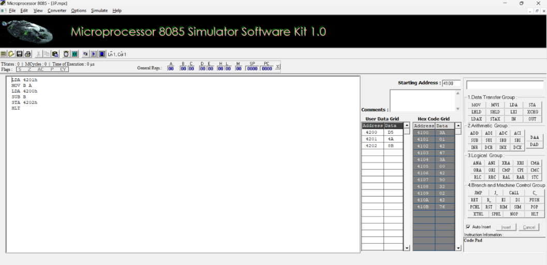

d. 8-BIT SUBTRACTION WITH BORROW USING DIRECT ADDRESSING
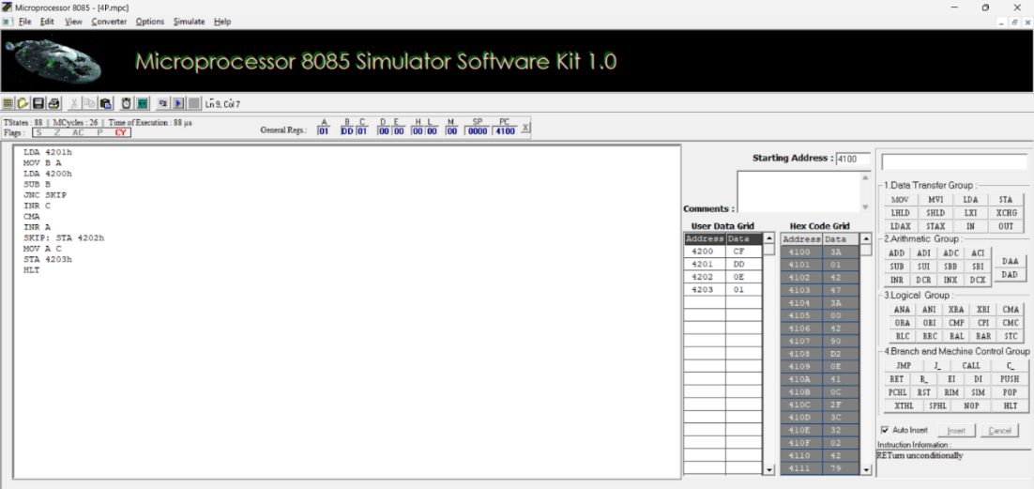

e. 8-BIT MULTIPLICATION OPERATIONS USING 8085 MICROPROCESSOR
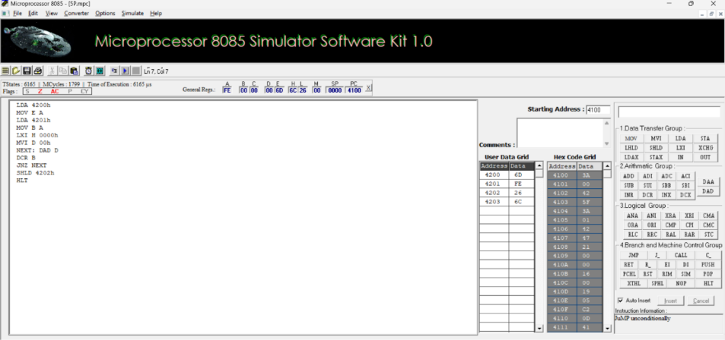
f. 8-BIT DIVISION OPERATIONS USING 8085 MICROPROCESSOR
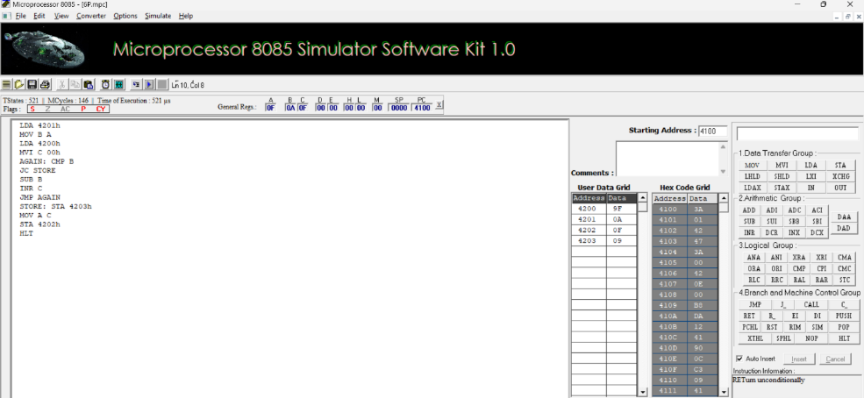

ASCII CODE TO HEX CODE CONVERSION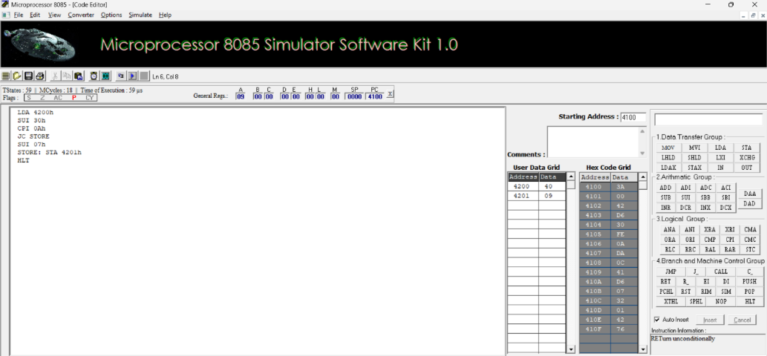

TRANSFERRING A BLOCK OF DATA BETWEEN MEMORY LOCATIONS
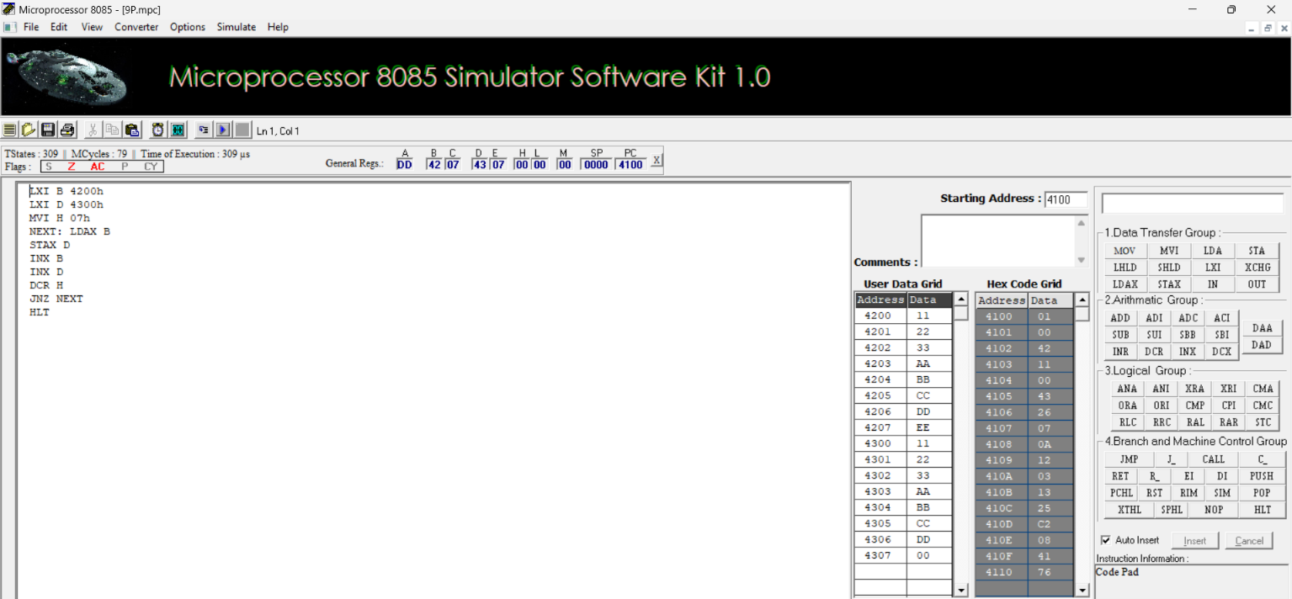

5a. MASKING AND SETTING OF LOWER NIBBLES ON GIVEN DATA
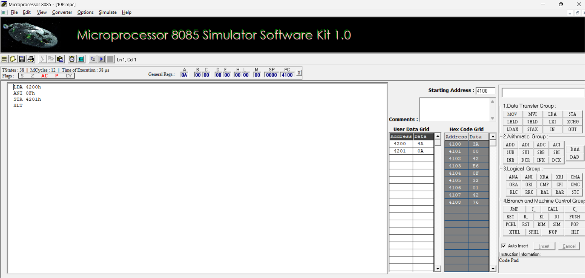
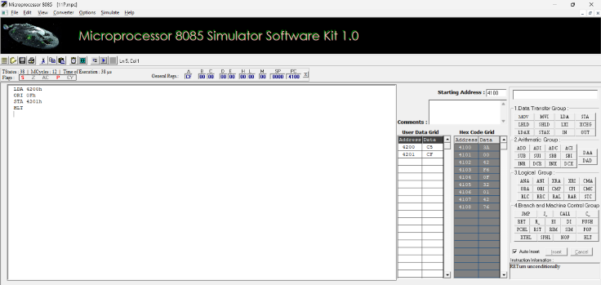

5b.ONE’S AND TWO’S COMPLEMENT
